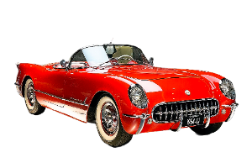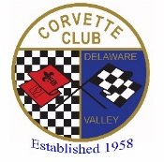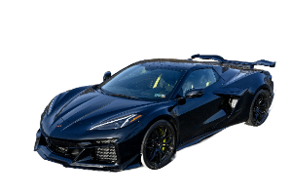

Corvette Club of Delaware Valley
Presents the 54th ANNUAL

CAVALCADE OF CORVETTES

Saturday, September 19, 2026 (8a-3p) Registration 8am to 10am - Rain Date: September 26, 2026

Middle Bucks Institute of Technology (MBIT) 2740 York Rd., Jamison, PA

Rare Corvettes, Music, Food, Charity Auction, Kids Activities, Over 60 Trophies, and More!

2026 Cavalcade of Corvettes Registration Form

Select Your Trophy Class (Circle One): Stock = 4 or less modifications from original. Modified = 5 or more mods. (Modifications from original include items such as: Gull wing doors, non-stock hood or spoiler, Custom Interior, Custom
bodywork or paint, non-stock wheels, Modified engine or transmission.)

C1 (1953-1962) Stock C5 (1997-2004) Stock C1 (1953-1962) Modified C5 (1997-2004) Modified
C2 (1963-1967) Stock C6 (2005-2013) Stock C2 (1963-1967) Modified C6 (2005-2013) Modified
C3 (1968-1982) Stock C7 (2014-2019) Stock C3 (1968-1982) Modified C7 (2014-2019) Modified
C4 (1984-1996) Stock C8 (2020-pres.) Stock C4 (1984-1996) Modified C8 (2020-pres.) Modified

Print Your Name: ___________________________________________ Cell Phone: _______________________

Address: _____________________________________________________________

City: _______________________ State: __________ Zip: _______________

Email Address (Print): _______________________________________________________________

Year: ________, Body Style (Circle): Coupe / Convertible, Equip (Z06, Z51, etc.): _______, Exterior Color: _________

US Military Veteran? If yes, Branch of Service: ___________________ Corvette Club Affiliation? _________________

T-Shirt Size (circle 1): S M L XL 2XL 3XL 4XL (Color of the newly designed shirt for this year is Black)

(Form & payment must be postmarked by August 12 to be considered as a pre-registered & receive FREE T-Shirt)
Undersigned participant assumes all risks & responsibilities of possible damage or injury involved through my participation in this activity. I understand that I am to furnish my own insurance in case of injuries suffered by me or to the property in consideration for my participation in this event. I also agree to abide by any rules & regulations set forth for this event. Alcohol, Drugs, & Firearms are strictly forbidden on the grounds during the event. Violators will be asked to leave the grounds. By signature below, I agree to these items.
Mail this form & a check for $30.00 (day of show is $35) payable to:
CCDV 2026 Cavalcade
C/O Jeff Kauf
726 S. Settlers Cir
Warrington, PA 18976

Your Signature: __________________________________________ Date: ___________________

