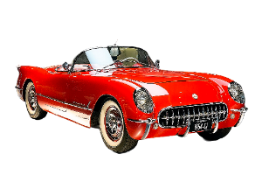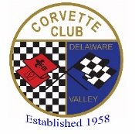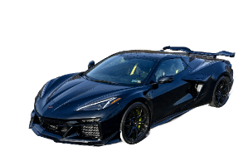

Corvette Club of Delaware Valley
Presents the 54th ANNUAL

CAVALCADE OF CORVETTES

Saturday, September 19, 2026 (8a-3p) Registration 8am to 10am - Rain Date: September 26, 2026

Middle Bucks Institute of Technology (MBIT) 2740 York Rd., Jamison, PA

Rare Corvettes, Music, Food, Charity Auction, Kids Activities, Trophies, and More!

2026 Cavalcade of Corvettes Vender Registration Form

Pre-registered Vendor Space (approx. 10x10 space):

$100 – food truck/food services
$75 – Non-food items (taking up 2 or more 10x10 spaces)
$25 - Non- food items
*Auto Related Products * Crafts* Other Specialty Items*
(Tents, Tables, Chairs, and Electricity – are vendor responsibility)

Vender Name: ______________________________________________ Cell Phone: _______________________

Address: _____________________________________________________________

City: __________________________ State: __________ Zip: _____________

Email Address (Print): _______________________________________________________________

Products/Services for sale: ______________________________________________

Bucks Co. Dept. Health License No. (Required for food sales): __________________

We reserve the right to restrict any vendor from participating/duplicates

*******************************
Mail this form and check (postmarked by September 1, 2026) payable to:

CCDV 2026 Cavalcade
C/O Jeff Kauf
726 S. Settlers Cir
Warrington, PA 18976

Question? Email Jeff @ kauf.jeff@gmail.com

Your Signature: __________________________________________ Date: ___________________

