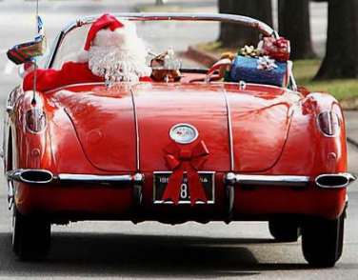
2025 CCDV HOLIDAY PARTY
SATURDAY, DECEMBER 6, 2025
6 pm to 10 pm

SPRING MILL COUNTRY CLUB
80 Jacksonville Road, Ivyland, PA 18974 (215) 675-6000

It’s that time again to start thinking of the Holiday Party.
Come join us for a fun night out, dinner, trivia, DJ & dancing!!

Your choice of dinner:
Chicken Marsala w/ Mushrooms, Marsala Wine, Garlic, & Shallots in a Demi-Glace, or North Atlantic Salmon w/ dill sauce, or Roasted NY Sirloin sliced w/ Bordelaise Sauce. Warmed Apple Turnover Dessert with French Vanilla Ice Cream
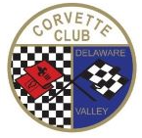
Hors D’oeuvres 6 pm – 7 pm
Sit-Down Dinner 7 pm – 8 pm
Rose & Dor’s Trivia Game 8 pm – 8:30 pm
Dancing 8:30 – 10 pm
CASH BAR
We are limited to 70 people, so reserve your spot early!

- - - - - - - - - - - - - - - - - - - - - - - - - - - - - - - - - - - - - - - - - - - - - - -
Payment Due by November 19, 2025
Mail checks payable to CCDV to:
John Benischeck – 15104 Dahlia Drive, Philadelphia, PA 19116
Chicken Marsala - $37.00
North Atlantic Salmon - $45.00
Roasted New York Sirloin - $50.00

Name ____________________________ Entrée Choice _______________________

Name ____________________________ Entre Choice ________________________

Payment Amount Enclosed $ _______________
If you have any questions, contact John Benischeck at 215-208-6620. Payments may also be handed in at our monthly membership meetings.

