2025 CAVALCADE OF CORVETTES

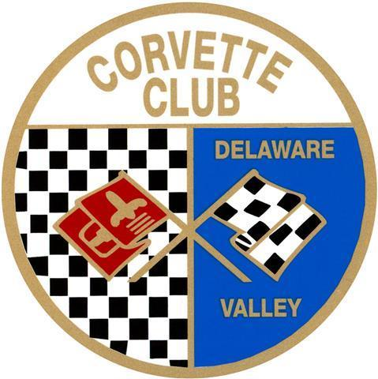Presented by the Corvette Club of Delaware Valley & Bryner Chevrolet

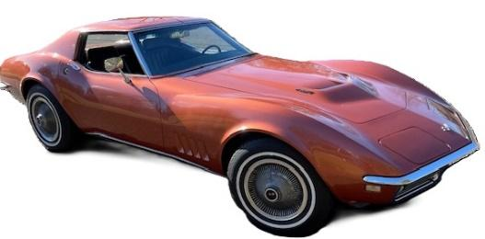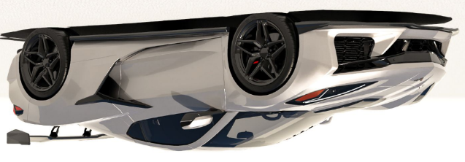

Date: Saturday, September 13, 2025 (Rain Date: Sat, Sept, 27, 2025)

ShowTime: 10am – 3pm (Vendor setup starts @ 8am – 10am)

Location: Middle Bucks Institute of Technology (MBIT)

2749 York Rd, Jamison, PA 18929 (go to [www.mbit.org](http://www.mbit.org) for directions)

**Pre-registered Vendor Space (approx. 10x10 space):**

$100 – food truck/food services

$75 – Non-food items (taking up 2 or more 10x10 spaces)

$25 - Non- food items

*Auto Related Products * Crafts* other specialty Items*

(Tents, Tables, Chairs, and Electricity – are vendor responsibility)

Vendor Name: _______________________________ Cell Phone: __________________

Address: ____________________________________________________________

City: ________________________________ State: ________ Zip: _____________

Email: _______________________________________________________________

Products/Services for sale: ______________________________________________

Bucks Co. Dept. Health License No. (Required for food sales): __________________

We reserve the right to restrict any vendor from participating/duplicates

*******************************

Mail this form and check (postmarked by September 1, 2025) payable to:

**Tim Simmons**

**c/o CCDV 2025 Cavalcade**

**3549 Brae Bourne Dr.**

**Huntingdon Valley, PA 19006-3049**

Questions: send email to Tim @ [tasimmons@gmail.com](mailto:tasimmons@gmail.com)