**Corvette Club of Delaware Valley**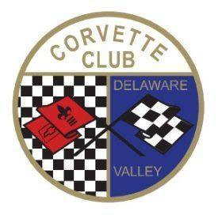

53rd Annual Cavalcade of Corvettes 2025

**Show Date: Saturday, September 13th (Rain Date Saturday Sept. 27th)**

**Middle Bucks Institute of Technology (MBIT) 2740 York Road, Jamison, PA 18929**

1. **Show Sponsorship – (Circle Sponsorship level desired)**

**Gold Show Sponsor ($500)**

* Name & Logo on 1/4 page in Club Monthly Newsletter, on Club Website, on Show Poster & FB page
* Your business name as Sponsor of a Major Trophy (see below and circle preferred choice)
* Include your provided Promotional items in Participant’s envelope
* Free vendor space to showcase your business the day of show

**Silver Show Sponsor ($250)**

* Name & Logo on 1/4 page in Club Monthly Newsletter, on Club Website, on Show Poster & FB page
* Your business name as Sponsor of a People’s Choice Trophy
* Include your provided Promotional items in Participant’s envelope

**Bronze Show Sponsor ($100)**

* Name & Logo on 1/8 page in Club Monthly Newsletter, on Club Website, on Show Poster & FB page
* Your business name as Sponsor of a Class Trophy (circle stock or mod choice and preferred place choice)
* Include your provided Promotional items in Participant’s envelope

Partial proceeds from the show benefit various Local Charities

1. **Trophy Sponsorship- (Circle desired category)**



**Corvette Class Trophies:**  **Major Trophies:**

ALL **TROPHY SPONSORSHIPS and MARKETING MATERIAL MUST BE RECEIVED BY AUGUST 1, 2025**

Company Name: __________________________________________________________________

Your Name: __________________________________________________________________

Cell: __________________________________________________________________

E-mail: __________________________________________________________________

Your Product/Service of business: __________________________________________________________

Questions? - Contact: Jeff Kauf @ [kauf.jeff@gmail.com](mailto:kauf.jeff@gmail.com)

Make checks out to CCDV and mail to:

Candy Merlino c/o CCDV Cavalcade Sponsorship 2135 Dixon Ave, Croydon, PA 19021