**53rd Annual Cavalcade of Corvettes**

Presented by the Corvette Club of Delaware Valley

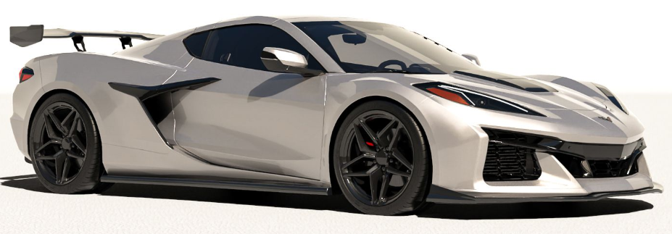

**Date: Sat., Sept. 13, 2025** (8a-3p) **Reg from 8-10 am sharp**/ Rain Date: Sat., Sept 27, 2025

**Location: Middle Bucks Institute of Technology (MBIT),** 2740 York Rd, Jamison, PA 18929

Music, Food, Charity Auction, 50/50 Raffles, Kids Activities, & Trophies

**Select Your Trophy Class (Circle One):**  **Stock = 4 or less modifications from original. Modified = 5 or more mods. (**Modifications from original include items such as: Gull wing doors, Non-stock hood or spoiler, Custom Interior, Custom bodywork or paint, Non-stock wheels, Modified engine or transmission.**)**Straight Connector 3

**C1 (1953-1962) Stock C5 (1997-2004) Stock C1 (1953-1962) Modified C5 (1997-2004) Modified**

**C2 (1963-1967) Stock C6 (2005-2013) Stock C2 (1963-1967) Modified C6 (2005-2013) Modified**

**C3 (1968-1982) Stock C7 (2014-2019) Stock C3 (1968-1982) Modified C7 (2014-2019) Modified**

**C4 (1984-1996) Stock C8 (2020-pres.) Stock C4 (1984-1996) Modified C8 (2020-pres.) Modified**

**2025 Cavalcade of Corvettes Registration Form**

Print Your Name: ___________________________________________ Cell Phone: ___________________

Address: _____________________________________________________________

City: _______________________ State: __________ Zip: _______________

Print Your Email Address: _______________________________________________________________

Year: ________ Body Style (Coupe/Conv): __________ Equip (Z06, Z51, etc.): ________ Exterior Color: _________

Club Affiliation (if any): ______________________________________

US Military Veteran?  Yes / No      Branch of Service: ____________________________

T-Shirt Size (circle 1): S M L XL 2XL 3XL 4XL Color: white **or** light blue

(Form & payment must be **postmarked by Sept. 1st** to be considered as a Pre-registered & receive free T-Shirt)

Undersigned participant assumes all risks & responsibilities of possible damage or injury involved through my participation in this activity. I understand that I am to furnish my own insurance in case of injuries suffered by me or to the property in consideration for my participation in this event. I also agree to abide by any rules & regulations set forth for this event. **Alcohol, drugs, & Firearms are strictly forbidden on the grounds during the event**. Violators will be asked to leave the grounds. By signature below, I agree to these items.

Day of show price is $30 Judging will start at 11 am $100 prize for best club participation

**Mail this form & a check for $25 payable to:**Straight Connector 4

**Tim Simmons**

**c/o CCDV 2025 Cavalcade**

**3549 Brae Bourn Dr.**

**Huntingdon Valley, PA 19006-3049**

Your Signature: __________________________________________Date: ___________________ v4