Corvette Club of Delaware Valley presents the
2024 Cavalcade of Corvettes
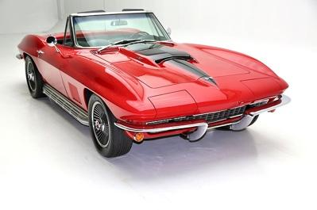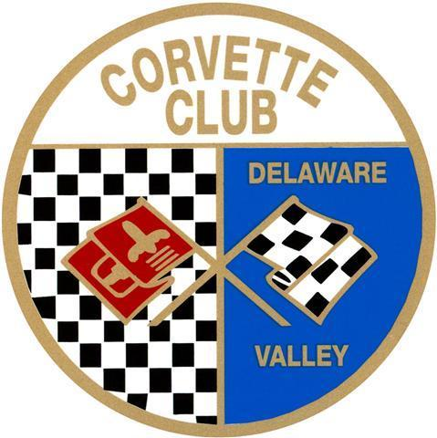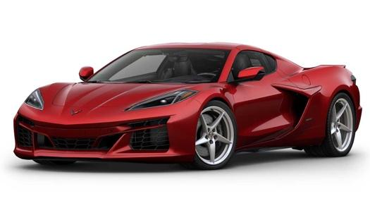
Date: Saturday, September 14, 2024 (Rain Date: Sat, Sept, 28, 2024)
Time: 10am – 3pm (Registration starts @ 8am)
Location: Middle Bucks Institute of Technology (MBIT)
2749 York Rd, Jamison, PA 18929 (go to www.mbit.org for directions)
Pre-registered Vendor Space (approx. 10x10 space):

$100 – food truck/food services
$25 - Non- food items
*Auto Related Products * Crafts* other specialty Items*
(Tents, Tables, Chairs, and Electricity – are vendor responsibility)
Vendor Name: _______________________________ Cell Phone: _____________
Address: ____________________________________________________________
City: ________________________________ State: ________ Zip: _____________
Products/Services for sale: ______________________________________________
Bucks Co. Dept. Health License No. (Required for food sales): __________________

We reserve the right to restrict any vendor from participating/duplicates

*******************************
Mail this form and check (postmarked by August 11, 2024) payable to:
CCDV – Cavalcade Vendor 2024
c/o Penelope Hunt
40 Mary Jane Lane
Newtown Square, PA 19073
Questions: send email to Penelope @ cocregistration@ccdv.com

