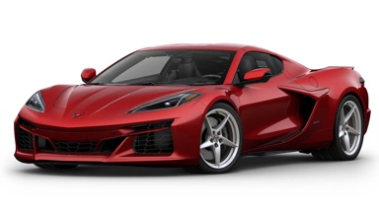
52nd Annual Cavalcade of Corvettes
Date: Saturday, September 14, 2024 (10a-3p) Registration starts @8am/ Rain Date: Sept 28, 2024
Location: Middle Bucks Institute of Technology (MBIT), 2740 York Rd, Jamison, PA 18929
Food, Music, Charity Auction, Door Prizes, 50/50 Raffle, Kids Activities, Trophies, All New Judging

2024 Cavalcade of Corvettes Registration Form

Print Your Name: ___________________________________________ Cell Phone: _______________

Your Address: __________________________________________________

City: _______________________ State: __________ Zip: _______________

Print Your Email Address: _______________________________________________________________

Are you a US Military Veteran? Yes / No Branch of Service: ___________________

Your Corvette Year: ___________ Body Style (Coupe/Conv): __________ Equip (Z06, Z51, etc): _____

Exterior Color: ________________ Club Affiliation (if any): ___________________________________

T-Shirt Size (circle one): S M L XL XXL 3XL (free T-Shirt to all Pre-registered by Aug 11th participants)

Select Your Trophy Class (Circle One):
Stock = 4 or less modifications from original. Modified = 5 or more modifications. (see reverse side for Judging criteria)

C1 (1953-1962) Stock C1 (1953-1962) Modified
C2 (1963-1967) Stock C2 (1963-1967) Modified
C3 (1968-1982) Stock C3 (1968-1982) Modified
C4 (1984-1996) Stock C4 (1984-1996) Modified
C5 (1997-2004) Stock C5 (1997-2004) Modified
C6 (2005-2013) Stock C6 (2005-2013) Modified
C7 (2014-2019) Stock C7 (2014-2019) Modified
C8 (2020-pres) Stock C8 (2020-pres) Modified

Mail this form & a check for $20 payable to:
CCDV 2024 Cavalcade
c/o Penelope Hunt
40 Mary Jane Ln, Newtown Square, PA 19073
The undersigned participant assumes all risks & responsibilities of possible damage or injury involved through my participation in this activity. I understand that I am to furnish my own insurance in case of injuries suffered by me or to the property in consideration for my participation in this event. I also agree to abide by any rules & regulations set forth for this event. Alcohol, drugs, & Firearms are strictly forbidden on the grounds during the event. By signature below, I agree to these items.
Your Signature: __________________________________________Date: ___________________

