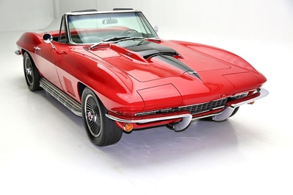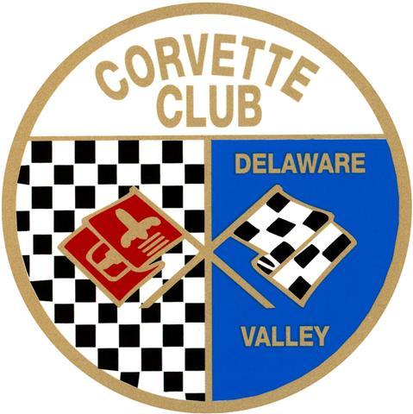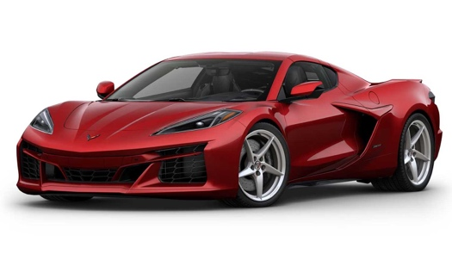

Date: Saturday, September 14, 2024 (Rain Date: Sat, Sept 28, 2024)
Time: 10am – 3pm (Registration starts @ 8am)
Location: Middle Bucks Institute of Technology (MBIT)
2749 York Rd, Jamison, PA 18929 (go to www.mbit.org for directions)

New Judging Format for 2024:
For Non-CCDV Members: Trophies Awarded for 1st, 2nd, 3rd place in each class (Stock or Modified, C1 thru C8), also Best in Show, Sunshine Foundation, Veteran’s Choice (chosen by a Vet), Kids Choice Best License Plate, $100 for Best Club Participation
For CCDV Members: 10 Trophies will be awarded based upon participant voting.

(Early departures forfeit trophy * No Alcohol Permitted on premises)

*Free to Spectators * Music * Food * Charity Auction * 50/50 Prizes * Kids Activities * Indoor Restrooms * Over 200 Corvettes on display * Vendor Spaces Available*

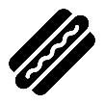

Partial proceeds benefit local charities

**Enter your Corvette**
Registration Form Available at: www.ccdv.com/cavalcade-of-corvettes
Or contact Penelope Hunt @ (cocregistration@ccdv.com)
$20 Pre-registration / $25 Day of Registration
Free T-shirt to all pre-registered participants

